Forest fires in Europe
What is a wildfire?
Wildfire is a general term which includes forest fires, grassland fires, bushfires, brush fires, peat fires and any other vegetation fire in countryside areas. Wildfires occur on every continent except Antarctica. They can occur naturally, but many are caused by humans, accidentally or deliberately.
A wildfire is simply an uncontrolled fire that is wiping out large fields and areas of land. It is typically fires that started out of a lightning strike, or people carelessly starting it, or accidentally, or even arson, that went un-noticed and got out of hand. These fires sometimes burn for days and weeks. They can wipe out an entire forest and destroy almost every organic matter in it. Note that these fires tend to thrive in very warm and dry climates, rather than the thick, moist rainforest types.
There are three conditions that need to be present in order for a wildfire to burn, which firefighters refer to as the fire triangle: fuel, oxygen, and a heat source.
This can be best explained in the fire triangle below.
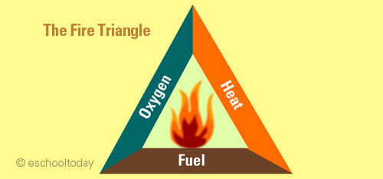

Wildfires and forests
The destructive nature of a wildfire in a forest is phenomenal. A forest is an entire ecosystem consisting of biotic factors like animals, insects, birds, bacteria, plants and trees. It also consists of abiotic factors like water, rocks and climate in that forest area. If a wildfire strikes such an ecosystem, all life forms will be lost. The air and water will be heavily polluted. The soils will be badly degraded and other abiotic elements will be affected including water catchment areas.
Different wildfires burn differently.
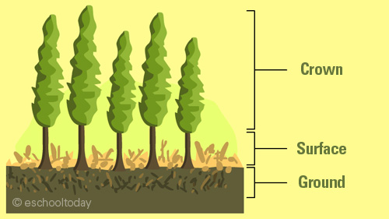
Fires that burn organic material in the soil are called ground fires. This is a slower burning fire, usually under litter or under vegetation. They burn by glowing combustion.
Some fires burn on the surface of the ground. They burn dry leaves, broken twigs and branches and other materials on the ground. These fires spread quickly and are known as surface fires.
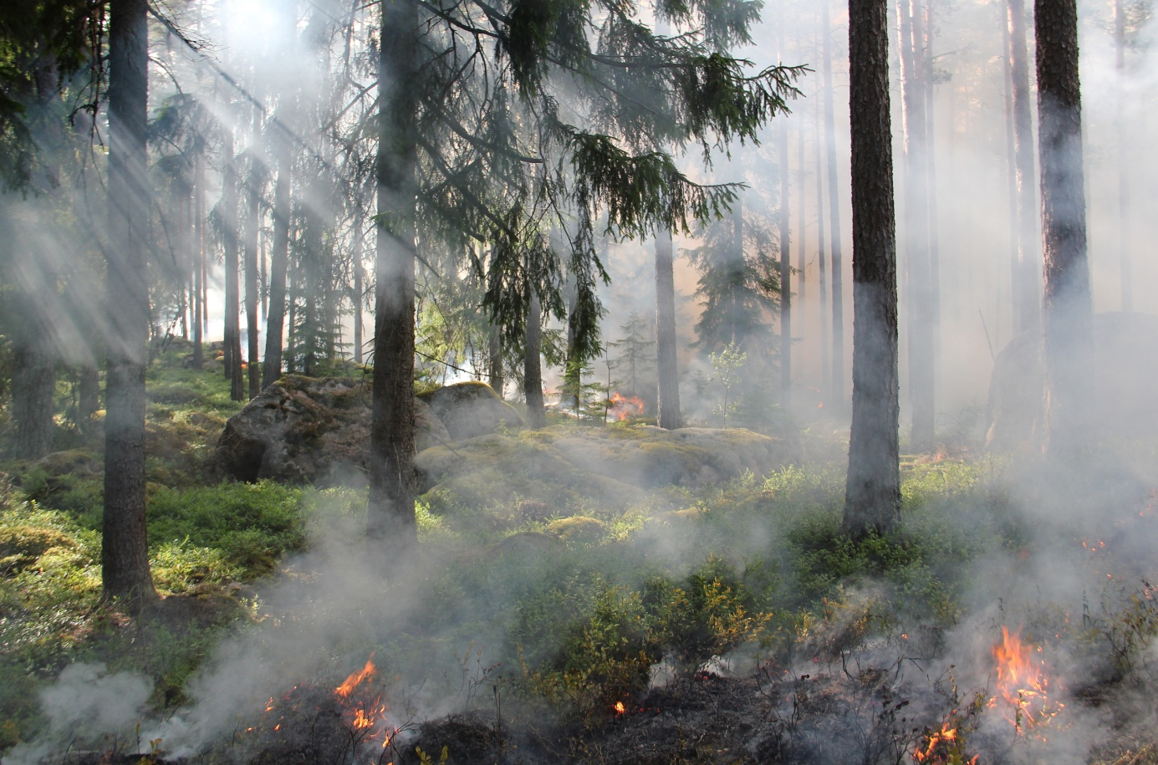
Crown fires burn with huge flames and has intense heat and power. They burn from tree top to tree top and spread very quickly with the wind and heat. It is even worse if they are exposed to steep slopes.
In 2003, over half a million hectares of woodland were destroyed by fires in southern Europe, causing several billion euros worth of damage.
See the fact file below for more information about forest fires.
- A wildfire moves at speeds of up to 14 miles an hour (23 kilometers an hour), consuming everything in its path. This includes trees, flowers, bushes, animals, and houses. Some wildfires can destroy an entire town and some of its residents.
- Lightning, burning campfires or cigarettes, hot winds, and even the sun can all provide enough heat to spark a wildfire.
- Four out of every five wildfires are started by people.
- Many people now live in areas where wildfires frequently occur. Wildfires are becoming more intense because they are being extinguished before they are allowed to burn all the underbrush that acts as fuel. When fires do break out in these areas they are very intense because they have a lot of fuel.
- Dry weather and drought convert green vegetation into bone-dry, flammable fuel; strong winds spread fire quickly over land; and warm temperatures encourage combustion.
- Traditional methods of fighting a forest fire include water dousing and spraying fire retardants to extinguish existing fires. Clearing vegetation to create firebreaks starves a fire of fuel and can help slow or contain it. Firefighters also fight wildfires by deliberately starting fires in a process called controlled burning.
Source: kidskonnect.com; eschooltoday.com

